**Three-Tier AWS Infrastructure Deployment (with GitHub Integration and OIDC)**

This project demonstrates how to deploy a **secure**, **scalable**, and **highly available** three-tier architecture on AWS using **Terraform** and **GitHub Actions**. The infrastructure is automated via a CI/CD pipeline using **OIDC-based authentication**, eliminating the need for hardcoded AWS credentials.

The infrastructure is built on a well-structured Virtual Private Cloud (VPC) with the following components:

* VPC: Provides a logically isolated network environment.
* Subnets:
  + 2 Public Subnets (across two AZs) – for the **Web Tier**.
  + 2 Private Subnets (across two AZs) – for the **Application Tier**.
  + 2 Private Subnets (across two AZs) – for the **Data Tier**.
* Internet Gateway (IGW): Enables internet access for public-facing resources.
* NAT Gateway: Deployed in a public subnet to allow private resources to access the internet (without being exposed).
* Route Tables:
  + 1 Public Route Table – routes public subnets to the Internet Gateway.
  + 1 Private Route Table – routes private subnets (App Tier) to the NAT Gateway.

With the infrastructure design now defined, we can proceed to building it using **Terraform**. We'll structure our Terraform files to keep the code **modular**, **organized**, and **reusable**.

**Root Directory (3-tier-AWS-Architecture/)**

The following Terraform configuration files will reside in the **root folder**:

* main.tf – Entry point that configures the provider and calls the module.
* terraform.tf – Specifies provider requirements and Terraform settings.
* terraform.tfvars – Supplies values for input variables (e.g., region, environment).
* variables.tf – Declares reusable input variables for the root module.

**Module Directory (modules/network/)**

A reusable **network module** will live inside modules/network/. This modular structure keeps networking logic isolated and easy to manage.

Files inside the modules/network/ folder:

* main.tf – Defines resources such as VPC, subnets, gateways, and route tables.
* variables.tf – Declares variables used within the network module.
* output.tf – Defines outputs (e.g., VPC ID, subnet IDs) that can be referenced from the root module

The above folder should look like the following once all set up:

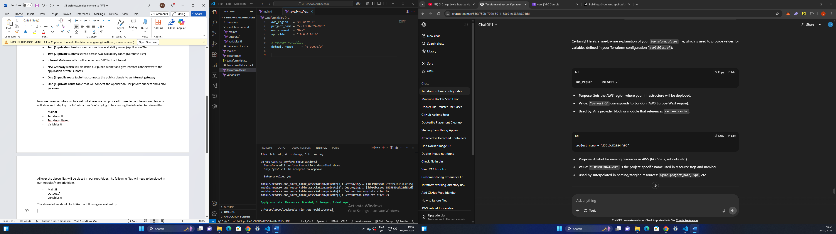

Root folder (3 tier AWS Architecture)

**Terraform.tfvars**

Terraform.tfvars is used to provide values for variables defined in our Terraform configuration (variables.tf):

**aws_region   = "eu-west-2"**

* Sets the AWS region where your infrastructure will be deployed
* "eu-west-2" corresponds to London (AWS Europe West region)

**project_name = "SJCLOUD2024-VPC"**

* A label for naming resources in AWS (like VPCs, subnets, etc.)
* "SJCLOUD2024-VPC" is the project-specific name used in resource tags and naming

**environment  = "Dev"**

* Specifies the environment (e.g., Dev, Test, Prod) you're working in
* "Dev" marks this infrastructure as part of the development environment

**vpc_cidr = "10.0.0.0/16"**

* Sets the IP range for the VPC using CIDR notation
* "10.0.0.0/16" allows for up to 65,536 private IPs

**# Network variables**

**default-route = "0.0.0.0/0"**

* Defines the default route for internet-bound or NAT-bound traffic
* "0.0.0.0/0" means "all IPv4 addresses" — i.e., the default route
* This is used by the **aws_route_table** to route traffic to the internet via an IGW or NAT gateway

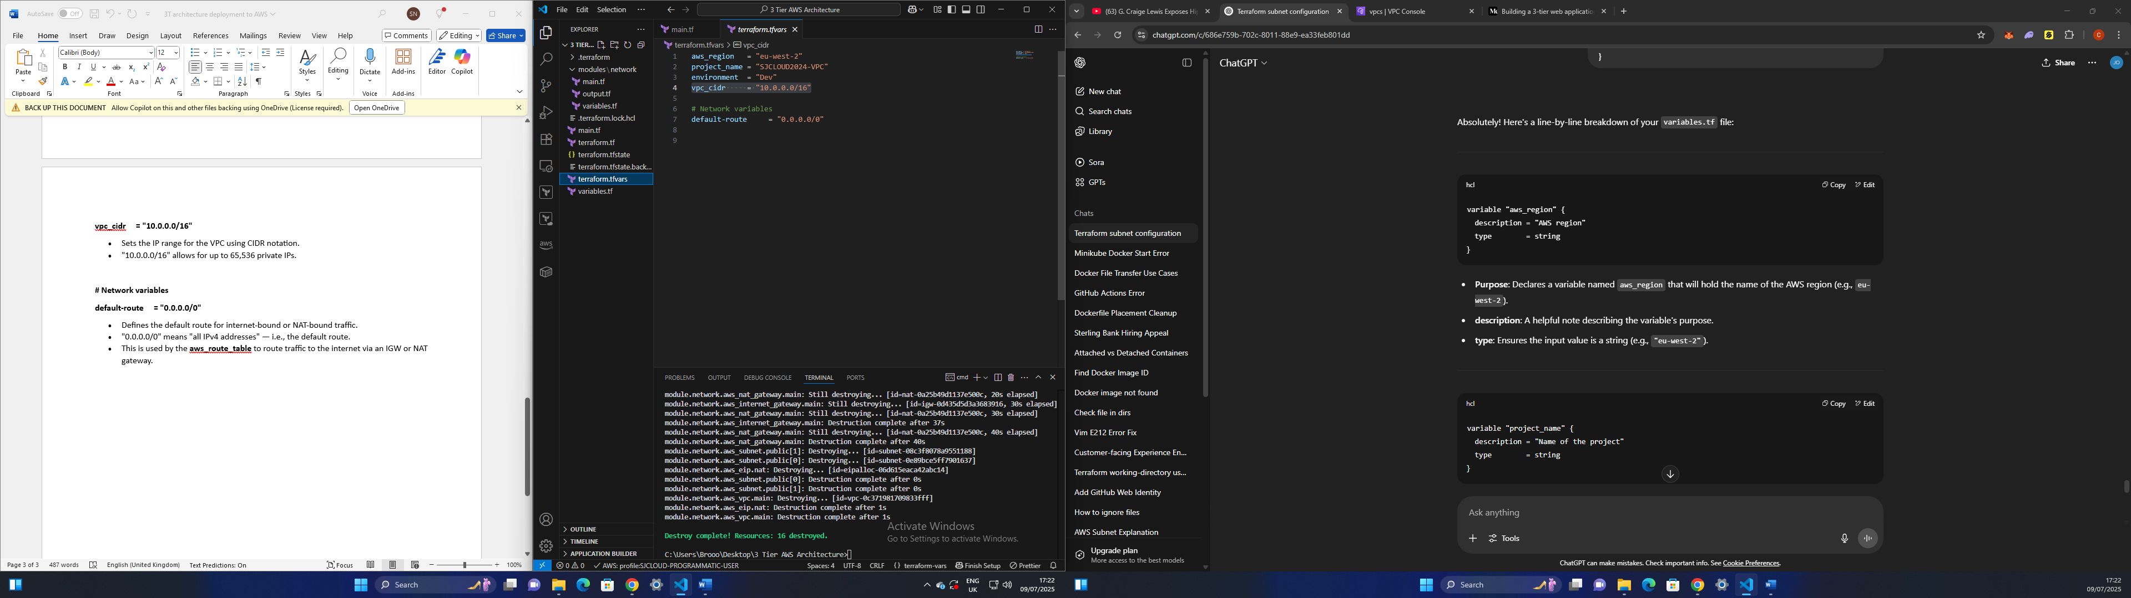

**Terraform.tf**

This file will hold our terraform configuration block that sets requirements for:

* Terraform version
* Providers used in this configuration (in this case AWS)

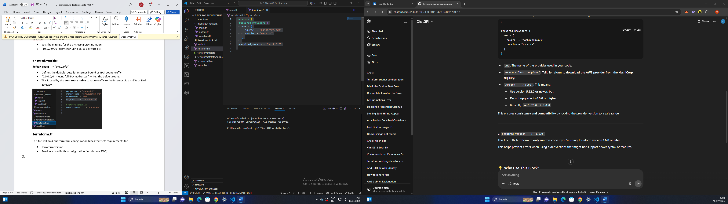

**Variables.tf**

A **variables file** in Terraform is used to define **input variables**—these are **dynamic values** that can be reused across your Terraform configurations.

Instead of hardcoding values directly into your .tf files (like the region, VPC CIDR, project name, etc.), you define them as variables and **pass them in from outside**, keeping your code:

* **Reusable**
* **Modular**
* **Secure** (you can keep secrets separate)

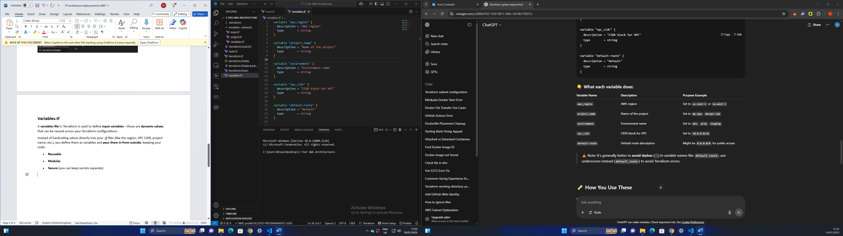

**Main.tf**

The main.tf file is the **main Terraform configuration file**. It acts as the **entry point** for defining infrastructure resources or calling **modules** that contain reusable infrastructure code.

**provider "aws" {**

**region = var.aws_region**

**}**

* provider "aws": This tells Terraform to use the **AWS provider**
* region = var.aws_region: The **AWS region** is set using a variable named aws_region, which has been defined in your variables.tf file

**module "network"**

* Declares a Terraform module named network
* A module is a reusable block of Terraform code
* This module will define our VPC, subnets, routes, etc

**source = "./modules/network"**

* Tells Terraform where to find the module’s code
* In this case, it's a **local directory**: modules/network

**default-route = var.default-route**

**project_name = var.project_name**

**vpc_cidr = var.vpc_cidr**

**environment = var.environment**

* We’ll create the above variables when we get to the module/network folder.

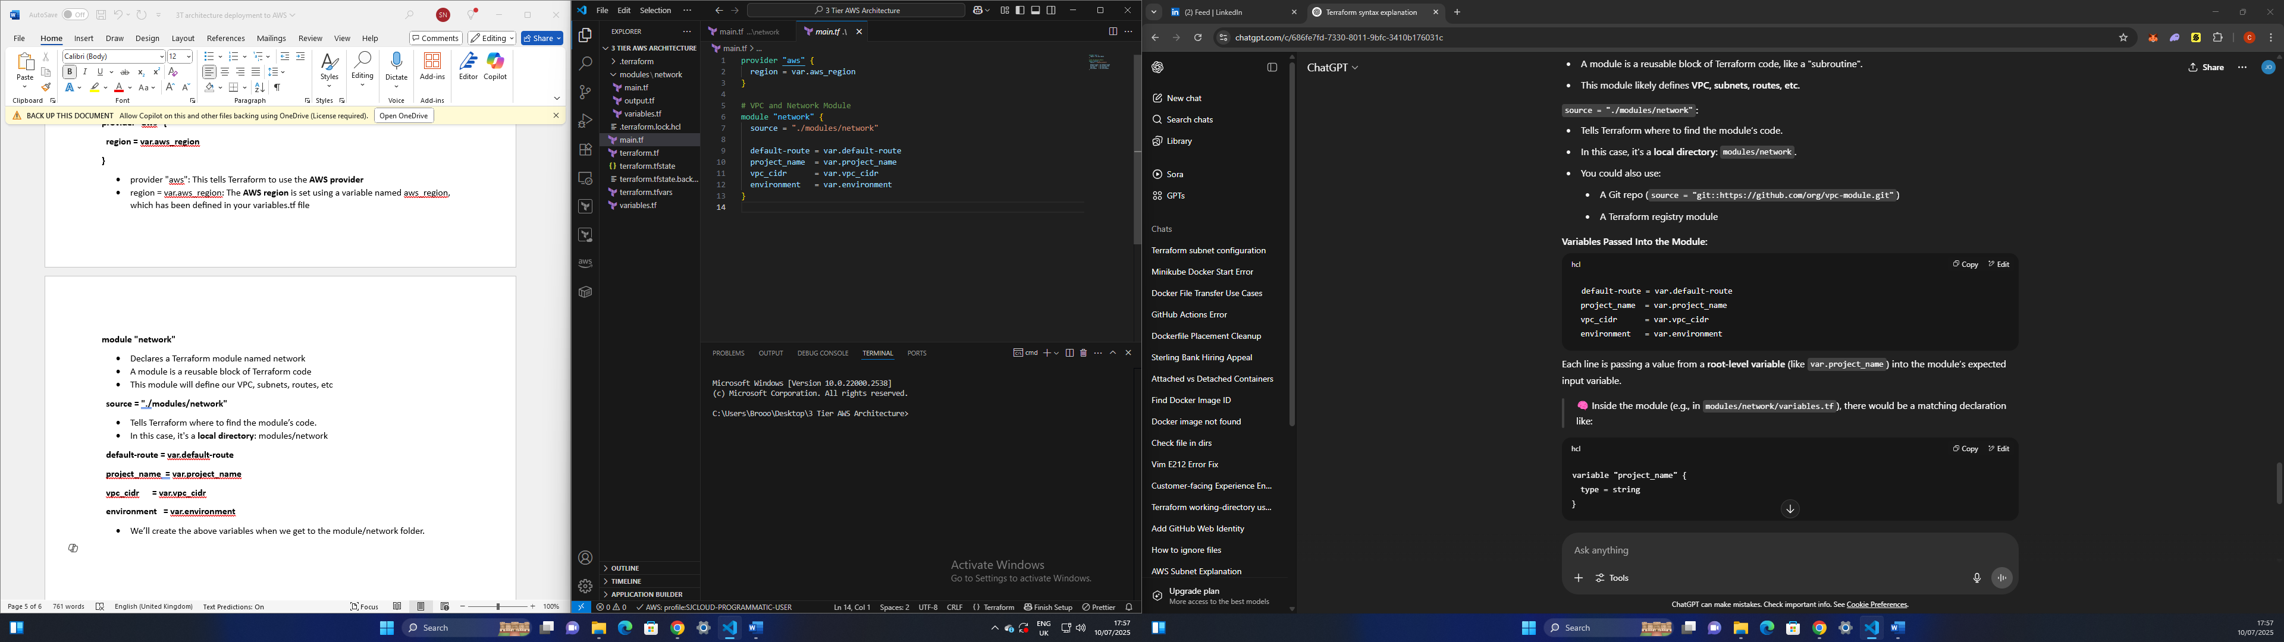

Modules/network folder

In the root folder, you will need to create a folder called ‘modules’ and within that folder you will need to create another folder called ‘network’. Our network folder will be home to our network module files.

**Variables.tf**

Just like in our root folder the variables.tf is used to define **input variables.**

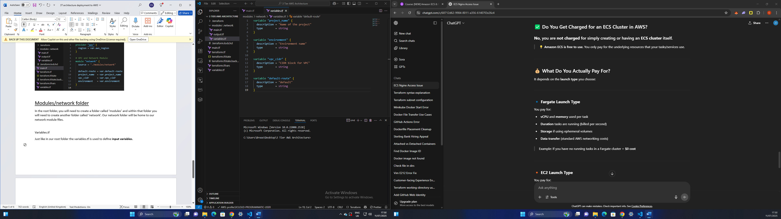

**Output.tf**

The outputs.tf file is used to define output values that Terraform displays after ‘terraform apply’. Think of it as a way to expose key information about your infrastructure once Terraform creates it. This can display VPC IDs, subnet IDs etc. In the below output.tf file we’ll be displaying the VPC id, subnet IDs.

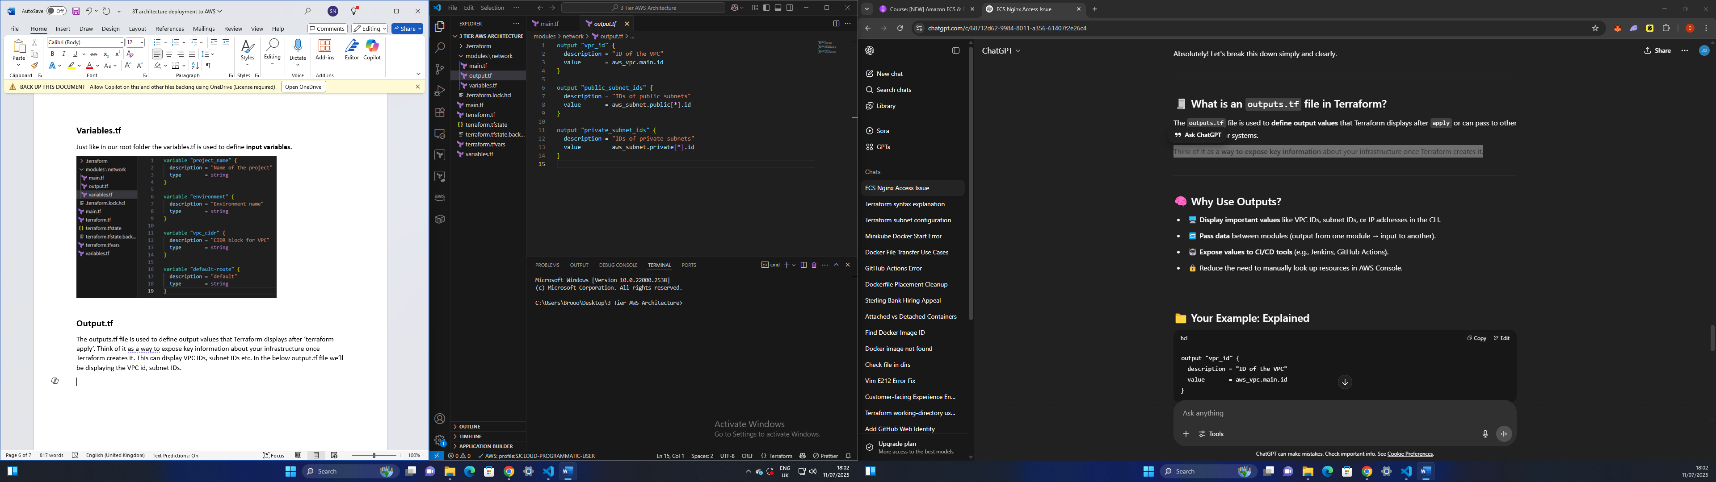

**Main.tf**

Our main.tf file will host the following resources which will make up our infrastructure:

* VPC
* Subnets
* Internet gateway
* NAT Gateway
* Route table
* Elastic IP

**VPC**

**data "aws_availability_zones" "azs" {} -** This is a data source that fetches information from AWS — specifically, the list of available Availability Zones (AZs) in the region defined in your AWS provider block.

**resource "aws_vpc" "main"**

* Tells Terraform to create an AWS VPC
* "main" is just the internal Terraform name used to reference this VPC elsewhere in the code

**cidr_block = var.vpc_cidr**

* Defines the **IP range** for the VPC using CIDR notation (e.g., 10.0.0.0/16)
* var.vpc_cidr is a variable, so this value is set in the variables.tf file

**enable_dns_hostnames = true**

* Enables assigning **DNS hostnames** to instances launched in the VPC
* Required if you want to use **Route 53**, **Private DNS**, or access EC2 instances by hostname

**enable_dns_support = true**

* Allows the VPC to **resolve DNS names** using Amazon-provided DNS
* Essential for accessing AWS services from within your VPC

**tags = { ... }**

* Adds **tags** to the VPC for easier identification and filtering in the AWS Console or CLI

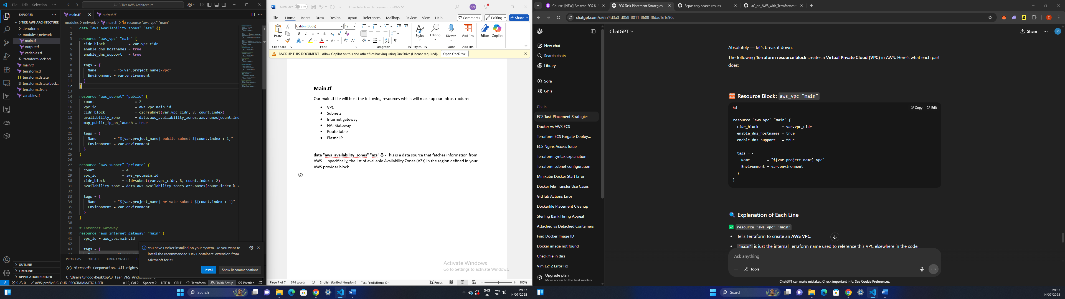

Note: syntax should look like the above.

**SUBNETS**

**Public subnet**

**count = 2**

* Creates **two** public subnets (index 0 and 1)
* Terraform will loop through the block twice, using count.index for indexing

**vpc_id = aws_vpc.main.id**

* Associates the subnet with the **VPC** you defined earlier (aws_vpc.main)

**cidr_block = cidrsubnet(var.vpc_cidr, 8, count.index)**

* Dynamically creates **non-overlapping subnet CIDR blocks** from your main VPC CIDR
* For example, if var.vpc_cidr = "10.0.0.0/16", it might generate:
  + 10.0.0.0/24 for index 0
  + 10.0.1.0/24 for index 1

cidrsubnet() ensures each subnet has a unique CIDR range inside the VPC block.

**availability_zone = data.aws_availability_zones.azs.names[count.index]**

* Distributes subnets **across multiple Availability Zones** for high availability
* Uses a data source to pull available AZs dynamically (defined at the beginning of this syntax)

**map_public_ip_on_launch = true**

* Automatically assigns a **public IP address** to EC2 instances launched in this subnet
* This is what makes it a **public subnet** (along with an Internet Gateway & route)

**tags = { ... }**

* Tags the subnet with a name like myapp-public-subnet-1, myapp-public-subnet-2
* Also adds an environment tag (e.g., dev)

**Private subnets**

**count = 4**

* Creates **4 private subnets** in total
* count.index will range from 0 to 3

**vpc_id = aws_vpc.main.id**

* Associates these subnets with the VPC defined earlier (aws_vpc.main)

**cidr_block = cidrsubnet(var.vpc_cidr, 8, count.index + 2)**

* Dynamically calculates a **unique subnet CIDR block** inside the main VPC range
* Starts at count.index + 2 so it doesn't overlap with the first two used for public subnets

Example: If var.vpc_cidr = "10.0.0.0/16", you might get:

* Index 0: 10.0.2.0/24
* Index 1: 10.0.3.0/24
* Index 2: 10.0.4.0/24
* Index 3: 10.0.5.0/24

**availability_zone = data.aws_availability_zones.azs.names[count.index % 2]**

* Alternates between **2 availability zones** using the modulo operator:
  + Index 0 → AZ 0
  + Index 1 → AZ 1
  + Index 2 → AZ 0
  + Index 3 → AZ 1

This distributes the 4 subnets **evenly across 2 AZs**, improving fault tolerance.

**tags = { ... }**

* Adds identifying tags for easier visibility and filtering in the AWS Console
* Example: myapp-private-subnet-1, myapp-private-subnet-2, etc

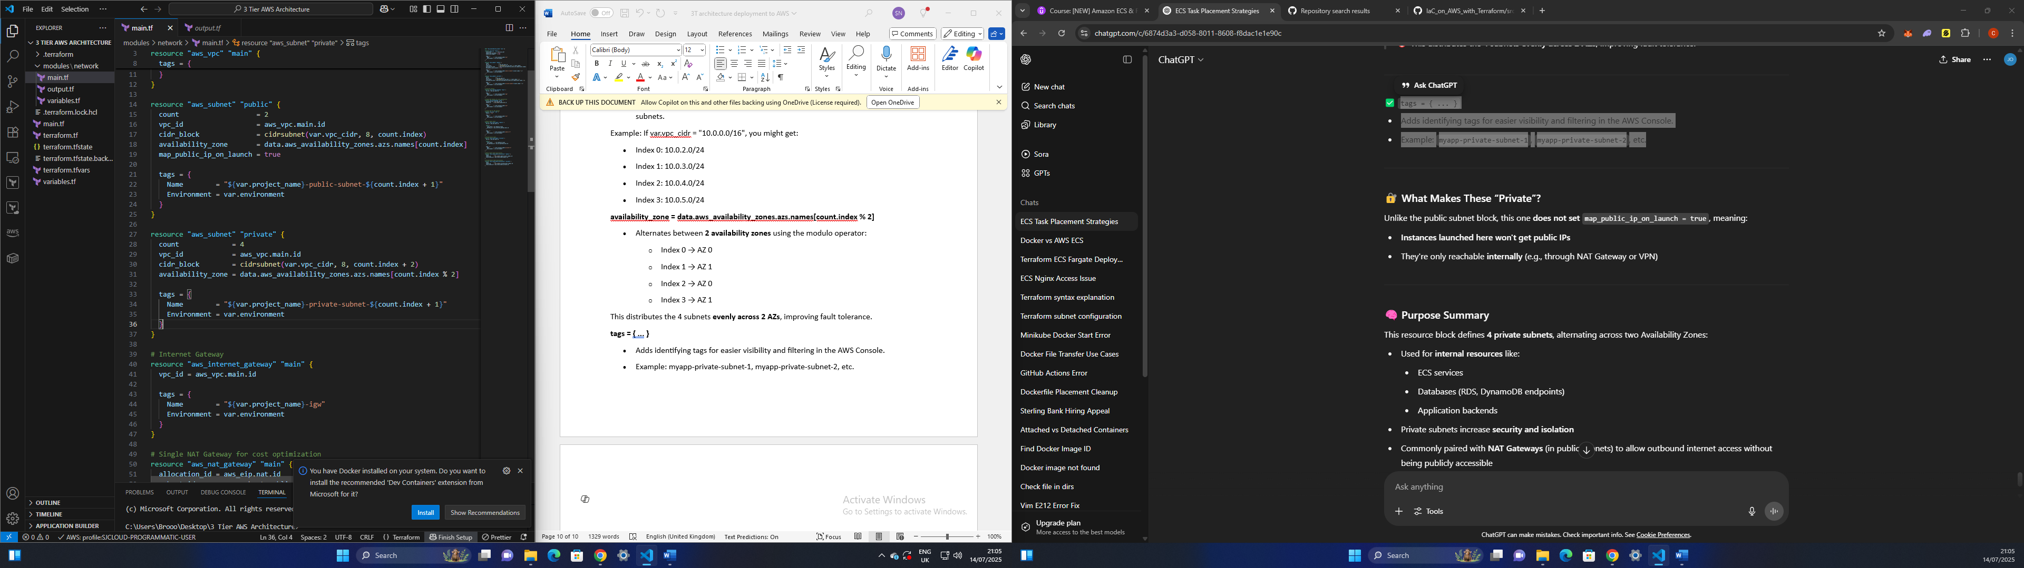

**Internet gateway**

An Internet Gateway (IGW) is a VPC component in AWS that allows communication between resources in your VPC and the internet.

**resource "aws_internet_gateway" "main"**

* Declares a new **Internet Gateway resource**
* "main" is the internal Terraform name, so you can reference this gateway elsewhere (e.g., in a route table)

**vpc_id = aws_vpc.main.id**

* Attaches the Internet Gateway to the **VPC created earlier**
* aws_vpc.main.id is a reference to your aws_vpc resource, linking them directly

**tags = { ... }**

Adds useful metadata (tags) to the IGW:

* Name: Gives the IGW a friendly name like myproject-igw
* Environment: Tags it as dev, prod, etc., which helps with organizing resources and managing environments

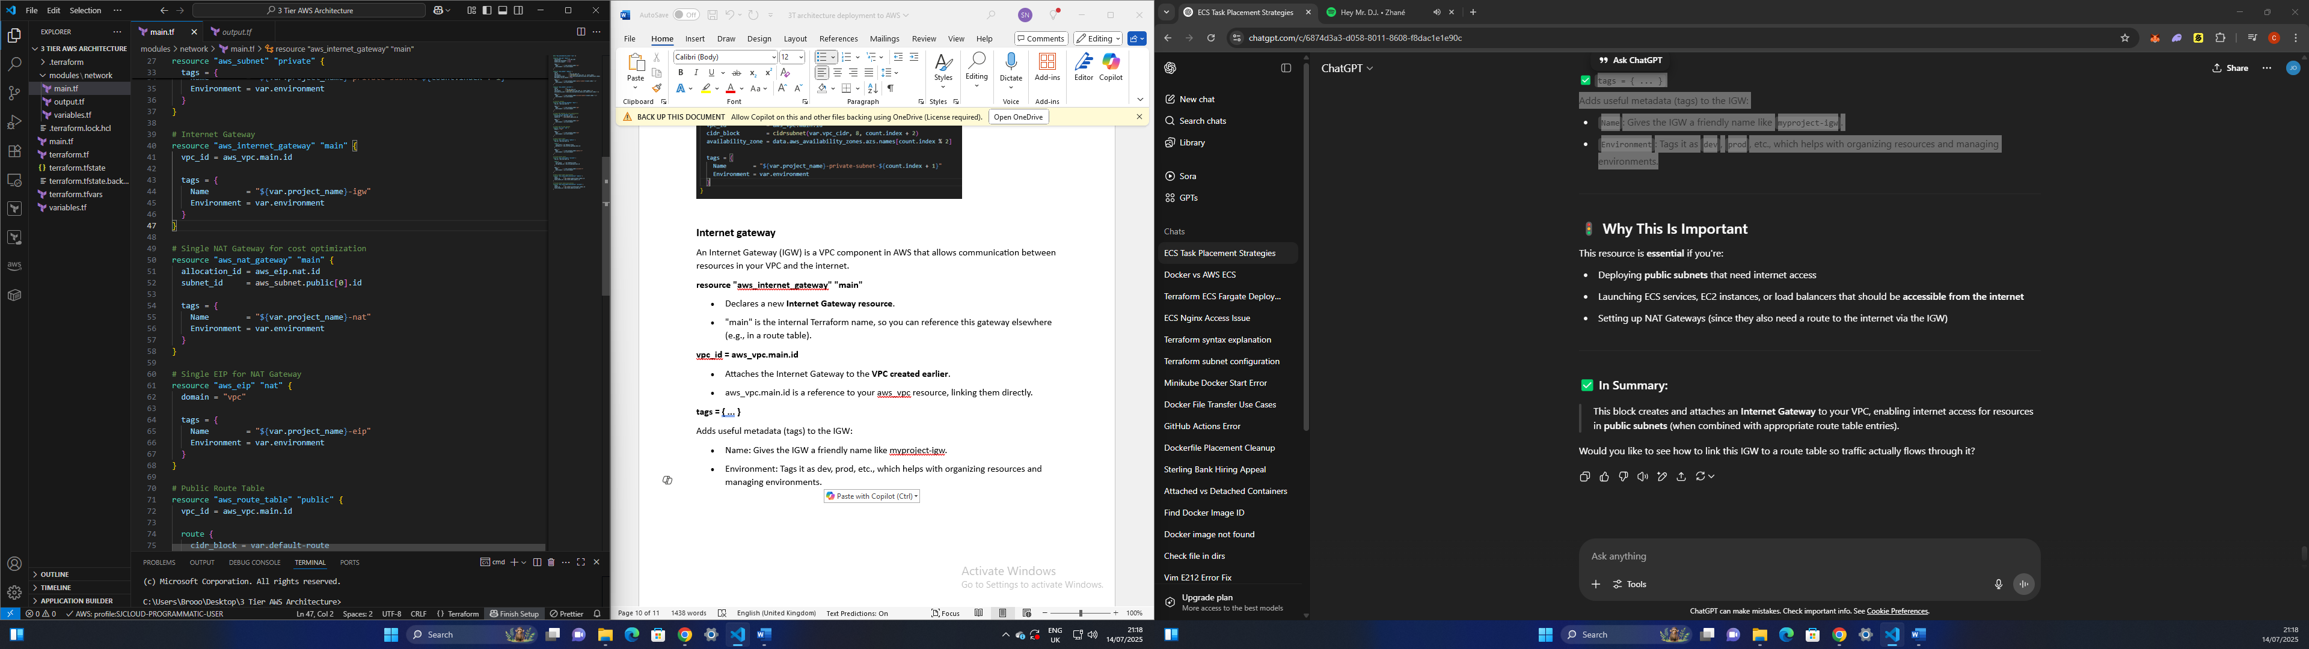

**NAT gateway**

A **NAT Gateway (Network Address Translation Gateway)** allows **private subnet resources** (like EC2 instances, ECS tasks, or databases) to access the internet without being directly exposed to the internet.

**resource "aws_nat_gateway" "main"**

* Declares a new **NAT Gateway** resource
* "main" is the Terraform reference name

**allocation_id = aws_eip.nat.id**

* Associates the NAT Gateway with an **Elastic IP (EIP)**
* This ensures the NAT Gateway has a **public IP address** for routing internet traffic

**subnet_id = aws_subnet.public[0].id**

* Places the NAT Gateway in a **public subnet**, which has a route to the internet via the Internet Gateway (IGW)
* This is necessary because the NAT Gateway needs to sit in a **public subnet** to function properly

**tags = { ... }**

* Tags the NAT Gateway for identification and organization in the AWS Console.
  + Name: Gives it a recognizable name like myproject-nat
  + Environment: Tags it with the environment (dev)

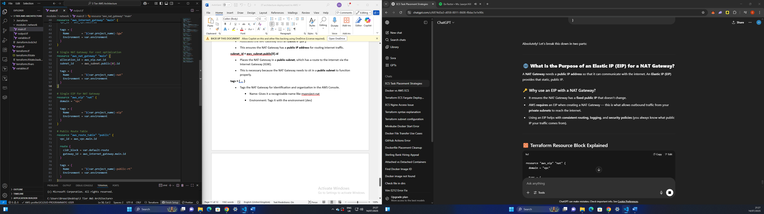

**EIP (Elastic IP) for NAT gateway**

A **NAT Gateway** needs a **public IP address** so that it can communicate with the internet. An **Elastic IP (EIP)** provides that static, public IP.

**resource "aws_eip" "nat"**

* Declares an **Elastic IP address** resource in Terraform
* "nat" is the internal Terraform name used for referencing this EIP in other resources (like the NAT Gateway)

**domain = "vpc"**

* This tells AWS that the EIP is being allocated **for use in a VPC** (which is the default and required for NAT Gateways)

**tags = { ... }**

* Adds metadata to your EIP for easier identification and filtering in the AWS Console:
  + Name: Names it like myproject-eip
  + Environment: Marks it as dev, staging, prod, etc

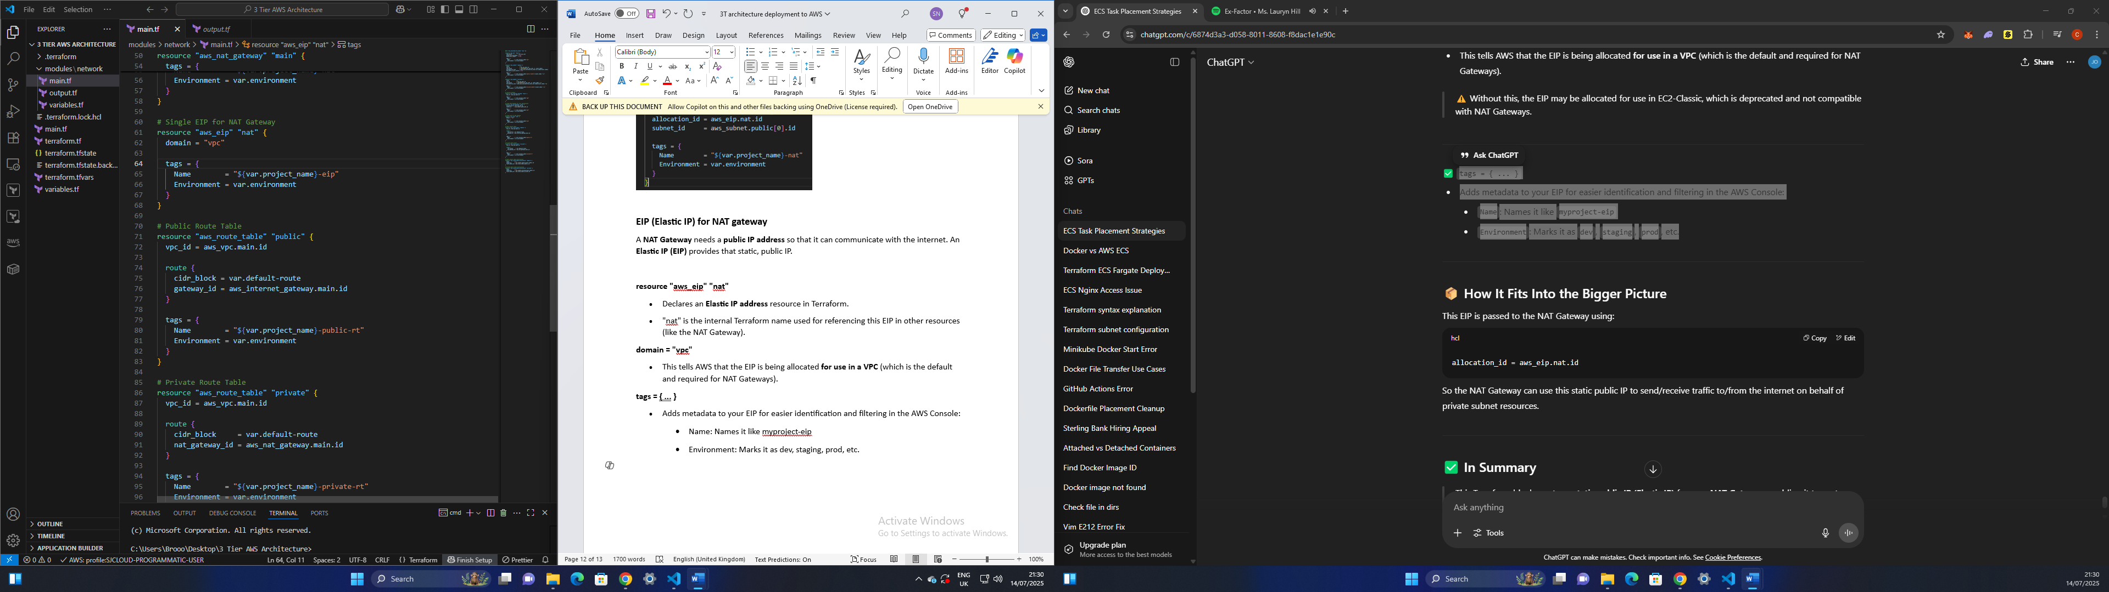

**Route Table (Public and Private)**

A public route table is used for subnets that need access to the internet and a private route table is used for subnets that should NOT have direct internet access.

**resource "aws_route_table" "public"**

* This creates a new **Route Table** in AWS and names it "public" in Terraform

**vpc_id = aws_vpc.main.id**

* Associates this route table with a specific **VPC**, referencing the ID from another resource (e.g., aws_vpc.main)

**route { ... }**

* This block defines a **route rule** for the table:
  + cidr_block = var.default-route  
    This is likely 0.0.0.0/0 meaning "all IPv4 addresses" (i.e., all traffic)
  + gateway_id = aws_internet_gateway.main.id  
    Routes that traffic **through the Internet Gateway** (IGW), allowing **public internet access**

**tags = { ... }**

* Adds metadata (tags) to the route table for identification:
  + Name: something like "myproject-public-rt"
  + Environment: e.g., "dev"

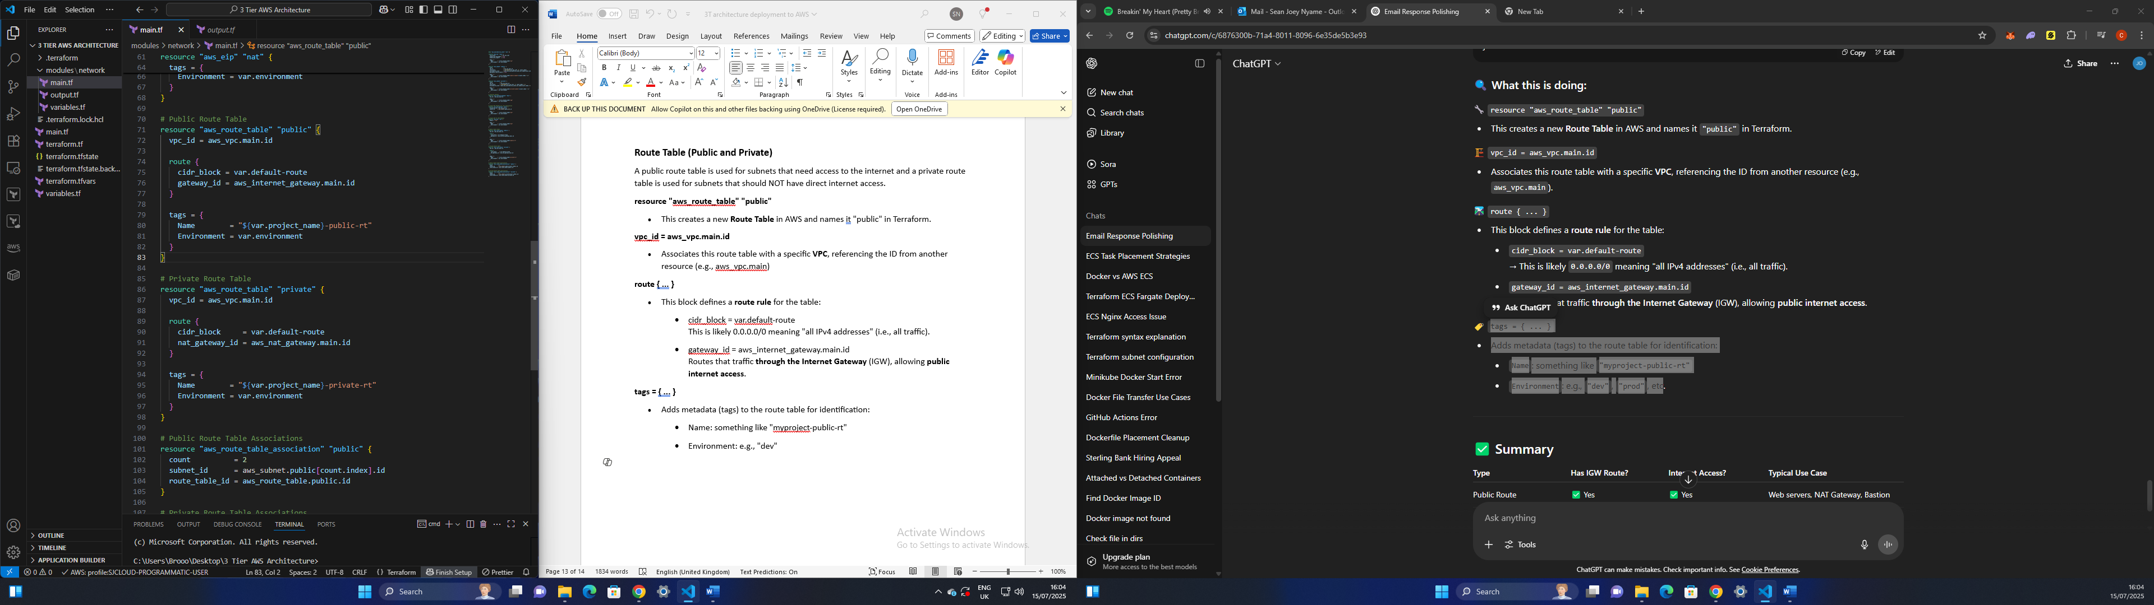

**resource "aws_route_table" "private"**

* This creates a new **Route Table** in AWS and names it "private" in Terraform

**vpc_id = aws_vpc.main.id**

* Associates this route table with a specific **VPC**, referencing the ID from another resource (e.g., aws_vpc.main)

**route { ... }**

* This block defines a **route rule** for the table:
  + cidr_block = var.default-route  
    This is likely 0.0.0.0/0 meaning "all IPv4 addresses" (i.e., all traffic)
  + nat_gateway_id = aws_nat_gateway.main.id  
    Routes that traffic **through the NAT gateway**

**tags = { ... }**

* Adds metadata (tags) to the route table for identification:
  + Name: something like "myproject-private-rt"
  + Environment: e.g., "dev"

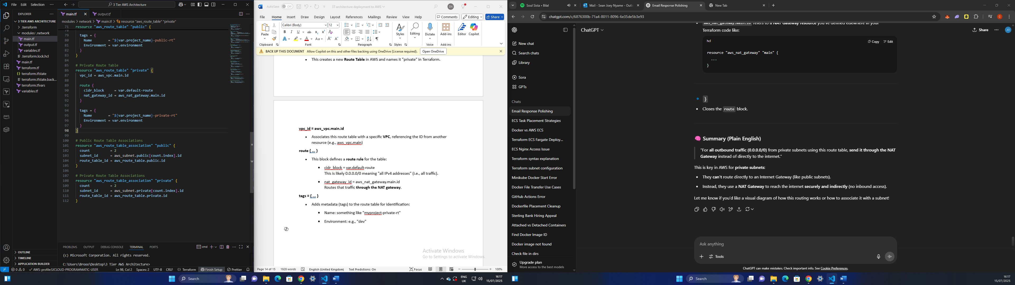

**Route table associations (Public and Private)**

In AWS:

* A Route Table defines how traffic is routed for a subnet
* But a Route Table does nothing on its own unless it’s associated with one or more subnets.
* Each subnet can be associated with one route table only

**resource "aws_route_table_association" "public" {**

* Declares a new AWS route table association
* "public" is the Terraform identifier

**count = 2**

* This means **create two instances** of this resource
* Likely because you have **two public subnets** (e.g., one per AZ)

**subnet_id = aws_subnet.public[count.index].id**

* Specifies which subnet to associate
* aws_subnet.public is a **list** of public subnets
* count.index is an iterator (0 and 1) used to loop through each subnet in the list
* This will grab aws_subnet.public[0].id and aws_subnet.public[1].id in two iterations

**route_table_id = aws_route_table.public.id**

* Tells AWS: “Associate each of these public subnets with the **public route table**”
* All subnets will **use the same route table**

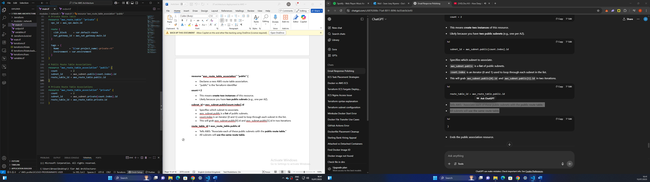

**resource "aws_route_table_association" "private" {**

* Declares a new AWS route table association
* "private" is the Terraform identifier

**count = 2**

* This means **create two instances** of this resource
* Likely because you have **two private subnets** (e.g., one per AZ)

**subnet_id = aws_subnet.private[count.index].id**

* Associates each private subnet (from the list aws_subnet.private) by its index

**route_table_id = aws_route_table.private.id**

* Associates both private subnets with the **private route table**

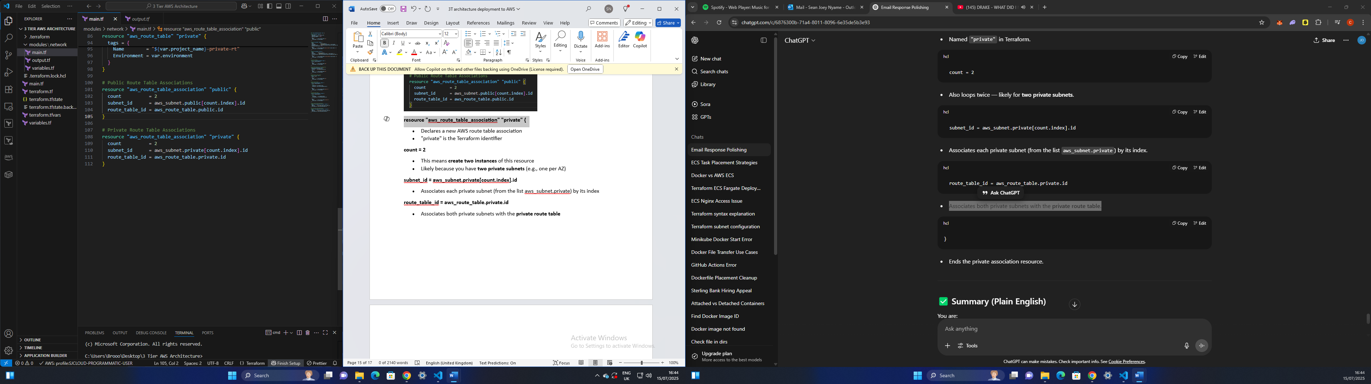

**GitHub Workflow file**

A **workflow file** in GitHub Actions automates tasks like CI/CD (Continuous Integration / Continuous Deployment) whenever events (e.g. push, pull_request) occur in your repository. In our case, this workflow file automates the deployment of infrastructure using Terraform to AWS whenever someone pushes to the master branch.

**name: "Terraform"**

* Gives the workflow a name shown in the GitHub Actions UI.

**on:**

**push:**

**branches:**

**- master**

* Trigger condition — this workflow runs only when a push is made to the master branch (this maybe master or main depending on the name of your branch).

**permissions:**

**id-token: write**

**contents: read**

* Grants the workflow permissions to:
  + id-token: write: Required for OIDC-based AWS authentication (secure and credentialless).
  + contents: read: Needed to read the code from the repository.

**jobs:**

**terraform:**

**name: "Terraform"**

**runs-on: ubuntu-latest**

* Defines a job named terraform. A job contains steps to run on a GitHub-hosted runner (like a VM)
* Label for this job in the GitHub Actions UI.
* Uses a virtual machine running the latest Ubuntu OS to execute this job.

**defaults:**

**run:**

**working-directory: AWS-DEPLOYMENT**

* Sets a default working directory (AWS-DEPLOYMENT/) for all shell commands (run:) to avoid repeating the path

**steps: block – Individual actions to run**

**- name: Checkout source code**

**uses: actions/checkout@v4**

* Checks out your GitHub repo code so Terraform can use it

**- name: Configure AWS credentials (OIDC)**

**uses: aws-actions/configure-aws-credentials@v4**

**with:**

**role-to-assume: ${{ secrets.AWS_IAM_ROLE }}**

**aws-region: eu-west-2**

* Authenticates with AWS using OIDC, without static credentials.
* Assumes the IAM role provided via GitHub Secret (AWS_IAM_ROLE) and sets the AWS region.

**- name: Setup Terraform**

**uses: hashicorp/setup-terraform@v3**

**with:**

**terraform_version: "1.6.0"**

**terraform_wrapper: false**

* Installs Terraform version 1.6.0
* Disables the wrapper (optional; used for legacy compatibility)

**- name: Terraform init**

**run: terraform init**

* Initializes Terraform (downloads backend config, providers, etc.)

**- name: Terraform plan**

**run: terraform plan**

* Runs terraform plan to preview changes Terraform will make to infrastructure

**- name: Terraform apply**

**if: github.ref == 'refs/heads/master'**

**run: terraform apply -auto-approve**

* Applies the infrastructure changes automatically (no manual approval).
* The if: condition ensures this runs only on the master branch to prevent accidents on other branches.

**- name: Terraform destroy**

**run: terraform destroy -auto-approve**

* Automatically destroys the infrastructure without confirmation

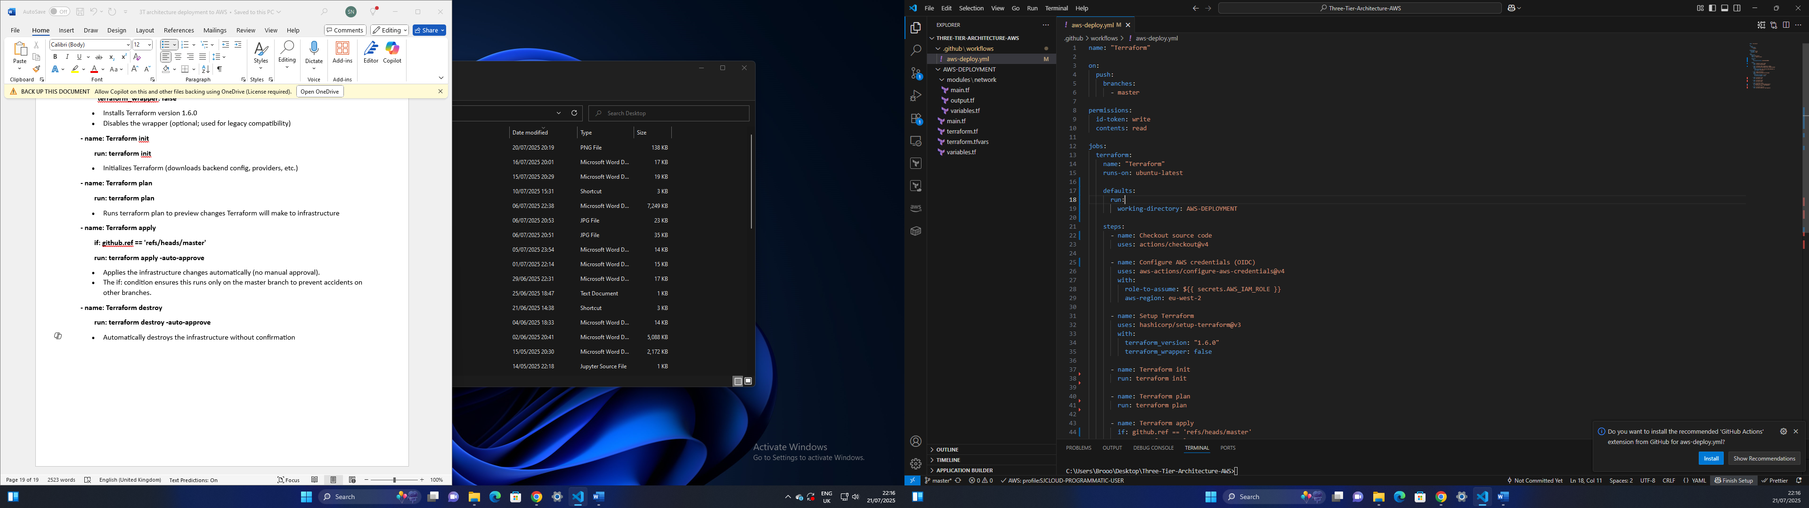

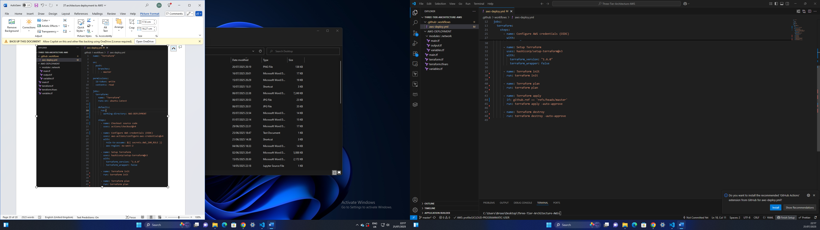

This project showcases my ability to provision and manage core AWS infrastructure — including VPCs, public/private subnets, route tables, internet/NAT gateways — using Infrastructure as Code (Terraform). The deployment is fully automated through GitHub Actions, leveraging OIDC (OpenID Connect) for secure, credential-free authentication to AWS.

This is the first project in a multi-part series where I will continuously integrate and deploy AWS resources using CI/CD pipelines, modular Terraform, and cloud-native best practices.